VS-600/800
Vacuum inflating packing machine

Operation Manual

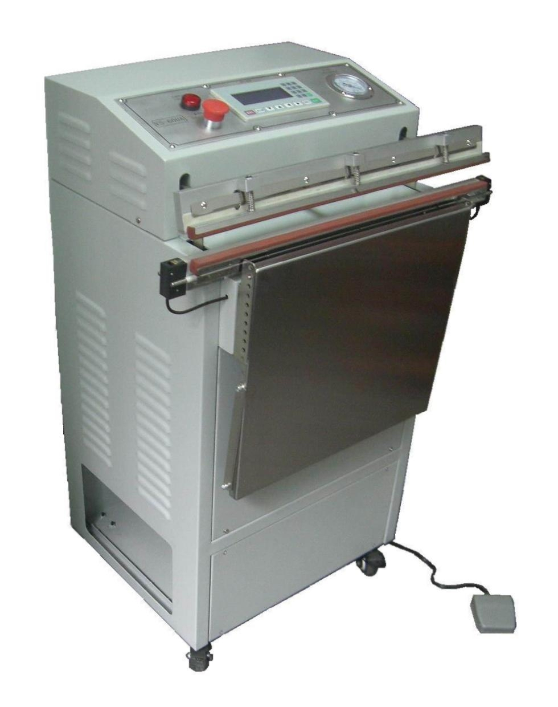

- Please read this manual carefully before using the machine
- If any technical innovation，Sorry for further notice

一、Preface
- How to correctly use this manual
  - Please read this manual carefully before starting machine for the first time
  - This manual explain the machine in detail.Please keep it with the machine
  - If the equipment need to be transferred or lent by third-party ，Please enclose the manual
  - Please don’t damage the manual
  - It’s not allowed to delete and modify the content without permission
  - Please do adjust the related technical parameters of the equipment according to the related guidance in this manual
  - Due to equipment performance constantly improve , Our company reserves the right to modify equipment and manual
  - Please contact us if any suggestion.
- Safety information
  - Must use same or bigger capacitance socket
The plug should be stably inserted in the socket directly

Danger！ The capacitance may different because of various Model，Make sure The socket and cable capacitance bigger than the machine capacitance. Stably insert in the socket directly. It may cause cable burn or fire if the capacitance is too small. Do use a suitable socket.
- This machine is not waterproof. Do not place the machine on wet ground.

Do not use this machine in a highly humid environment , do not let the machine contact to large amounts of water vapor
Using in the humid environment or the machine contact large amounts of water vapor may cause short circuit, shut down, electric shock.The Machine will get rust and fail insulation
- Don’t put and use the machine under dusty place
- Don’t put hand (s) into the sealing parts.
Danger！ The sealing parts have a clamping pressure action，so should pay attention to safety when operating。Although the first clamping pressure action is powered by a spring clamp .it will not cause too much harm to the operator. However, Once improper operation after clamping pressure(in the sealing and manual vacuum gear secondary trigger feet switch), so, the equipment will start clamping pressure action for the second time powered by two cylinder... In addition, it will damage the sealing silicone and sealing knife, shorten the service life of the related parts and components.

Caution：Please press the emergency button once above accident happen


- The acceptable air pressure is 5～7Kg/cm²，Insufficient pressure will result in abnormal work. Gas related components will be damaged by overpressure.
- Don't put hard objects in the sealing parts.
Caution! Before using this machine should realize that putting hard object in sealing parts not only damage sealing silicone, but also probably cause unexpected damage to air cylinder.
- The Vacuum inflating packing machine has some quick-wear part (such as, high temperature tape, Silicone seal, heating sealer) .Please regular checking ,Replace by a new one once the part is unable to use.
- Before replacing any parts, pull out the power plug first.
Caution！Please do maintenance properly according the manual instruction. Do switch off the power if replace any parts. We will not take any responsibility if the customer unauthorized change or upgrade the machine.
- Please read the manual carefully and properly operate the machine
Caution！We will not take any responsibility if any accident caused by improper operation。

二、Specification and Feature
- Specification
Item | VS-600/800
Power supply： | Single phase（3×1.5mm²）/220V/50Hz/1.5Kw
Air source： | 6～8 Kg/cm²
Seal dimensions： | L600/800×W8mm
Working table size： | L450×W400mm
Machine dimensions ： | L680/880×W500×H1000mm
Equipment main material: | Q235-A carbon steel coating processing
Net Weight： | 80/85kg
- Machine dimensions：
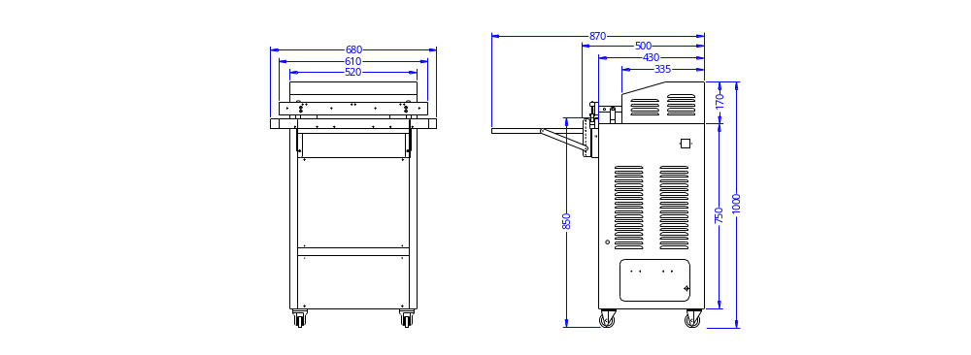
- Equipment composition and characteristics：
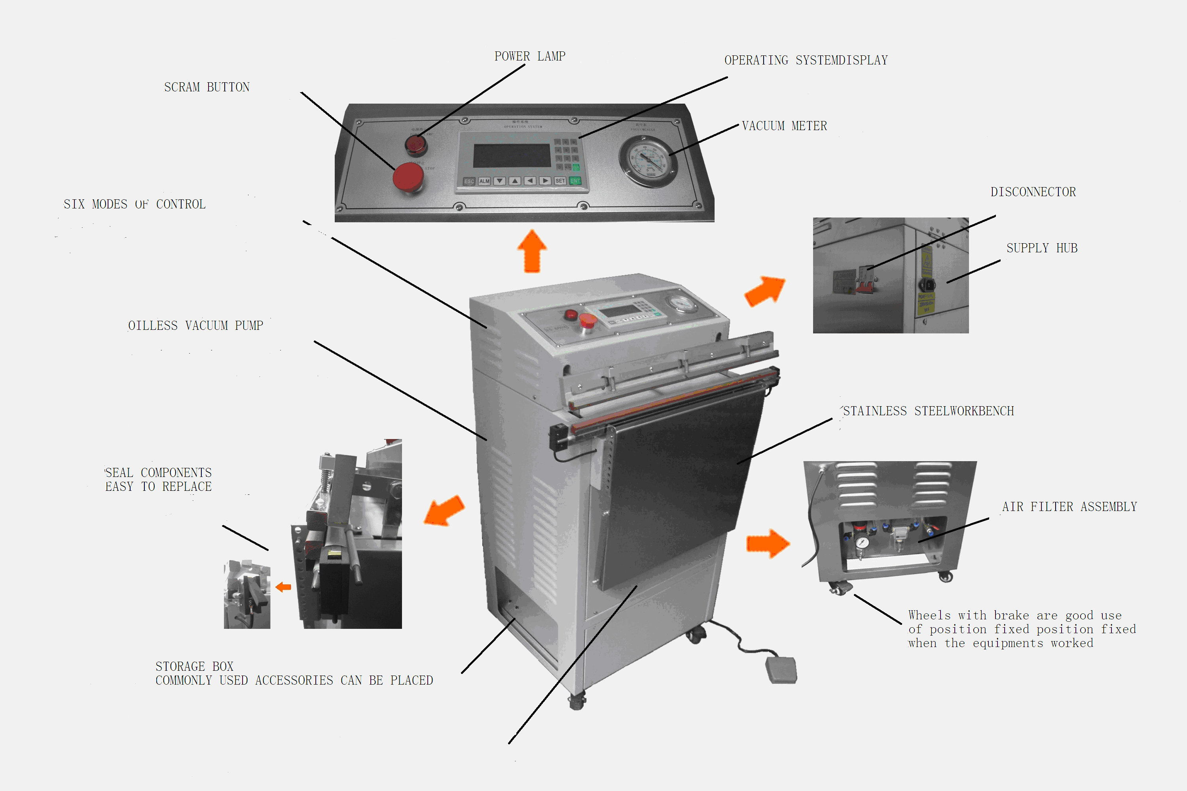
Three new technology protect the heating blade from burning
  - Single signal trigger：Using single signal trigger replace multi-signal signal trigger sealing heating mode. From the source to eliminate the caused by signal line not clear or many times which may cause burning blade;
  - Limit the maximum heating time：Not only on the Pannel display parameters setting for heating time setting of the upper limit of 2 seconds in the PLC program has also done a limit of 2 seconds. This double limit protection can ensure completely impossible due to human negligence to set the heating time is too long.
  - Frequent heating protection: Although the above two methods can ensure that the device itself will not trigger wrong heating signal, and single-heating time will not exceed 2 seconds. However, it is possible they may mistakenly set cooling time, vacuum time, inflation time and all to be short or zero. To avoid this possibility, we qualified in the program, completed after a heated again within 3 seconds to start the heating system instantly jump fault protection. (Press the stop button and then spin can be lifted from this failure to protect, but please immediately amend the related parameters, or the device is still not functioning properly.)
Foot switch will no longer appear "duplicate signal"
Procedural requirements in the first jog foot switch, you need to have been stepping on the pedal. If the lever pressed during the next abnormal condition occurs, you just let go of the pedal, the lever will be instantly lifted. Of course, as long as you do not release the trigger first foot, then no matter how long the stampede of the system, it will not be mistaken for a second shot;
  -  Second inching pedal shield prepared in the program, that means you are in a working cycle to repeat again how long jog or inching pedal, pedal systems will no longer be accepted. So you do not have to jog to deliberately control the length of time, or worry about the foot switch repeatedly to trigger action program caused confusion; (in the "manual vacuum" mode, it needs a third pedal, so this mode not available for triggering more foot pedal after the second re-trigger free. )
Working mode changeable during production
  - After we select a mode of operation, when the related operations being carried out, and they need to switch to another operating mode ...... the replacement program will help you to re-enter another operating mode you want to select the without causing confusion procedures;
Multiple vacuum modes selectable
  - Although the standard configuration is no oil pump, as each way has its advantages and disadvantages, we can provide a variety of ways for you to choose.
Multiple vacuum modes
Vacuum pump type | Vacuum degree | speed | Noise | Clean degree | Application
Oil-free vacuum pump | High | fast | weak | clean | widest applied
Oil Vacuum Pump | Highest | fasted | strong | Little oil | Require a relatively high degree of vacuum
Vacuum Generators | low | fast | middle | clean | Electronics and other less vacuum degree demanding but requires clean
Water circulation pump | High | fast | strong | clean | Water-insoluble or water vapor-containing dust products
a variety of sealing line width
  - Heat sealing equipment standard blade width is 8mm, it is only because of this sealing width with widest adaptation range. Customers can also choose other sizes such as 6mm or 10mm.
Optional vacuum control
  -  vacuum control equipment standards adopted for the "vacuum period" control, ie: the total time by controlling the pump to control the length of the vacuum bag vacuum mode, just using vacuum table indicates the approximate change in the actual value of the vacuum bag .
  - If you really need to, you can choose to use the real-time value of the vacuum bag to control, as long as the value of the vacuum bag to achieve your desired degree of vacuum on the vacuum immediately stopped.
- Control panel：
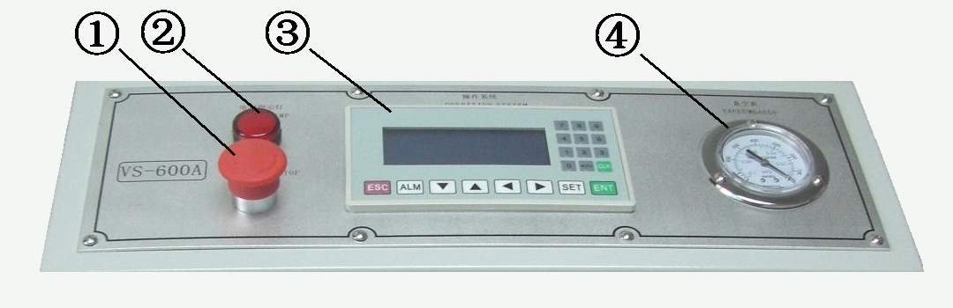
①Power light ---------------- Indicates whether the power is normal
②Emergency stop -------------Any urgency could stop the machine immediately
③Electronic operating system-----Equipment parameters setting and work mode selection
④Vacuum meter---------------- Monitor the vacuum degree in the bags
三、Equipment installation and use
- Installation：
- Remove the packaging ，Move the machine to the fixed position, Lock the trundle.
Warning：Do not use the machine at tilt, uneven or unstable place. otherwise the machine may fall and damage. Do not let the machine contact water or steam, or it may cause a short circuit and stop
- Measure the following parameters before start machine
Voltage：Single-phase three wire system（3×1.5mm²） / 220V / 50Hz
Average power：1.5Kw【The heatng blade and the vacuum pump cann’t start at same time】
compressed air：6～8kg/cm²【air pressure in the pipeline】
Warning：The machine must be reliable grounding！
- Machine start step：
- Connect to the air source correctly. (Adjust the pressure of working air source to 4-7 kg pressure, thus to open the sealing blade). Release the water if there are too much water in the oil-water separator.

- Insert the power plug directly into the socket.
Rotate the emergency stop button to ON position. Check if the red indicator is bright. After you have completed the inspection, the machine will change to standby status.
○ Standby Status: The press rod is on upper side while the air nozzle is on back side.
- Set the sealing and cooling time according to the material and thickness of the bag you select. Set the vacuum time or inflating according to your needs or the bag size.
- Select the working mode according manufacture requirement.，Operate the the machine according the operation procedure of the working mode.
warning：any unexpected status stop by emergency button.
- Parameter setting：
Switch on the machine you can enter home page of the operating system
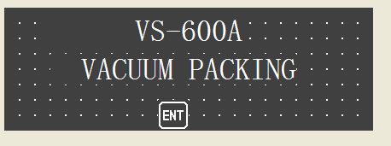

Press ENT you can enter the operating system main menu
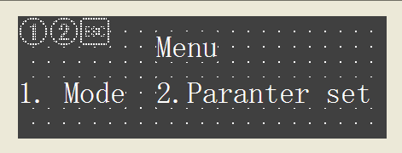
Select “2 enter Parameter Settings
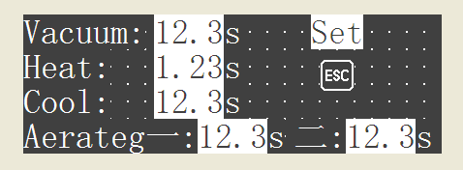
Press the SET button cursor will be the first in a "vacuum: I" at the flashing, indicating that at this point you can enter (entered directly from the right side of the keyboard or the up and down arrow keys to adjust the value) to set the desired target time. The left and right arrow keys to adjust the bit values. Note: After the completion of the required input by pressing the ENT key to save your input just do (otherwise the data will not be updated saved!), And the cursor will automatically jump to the "heating: I" of the flashes. If you do not need to change a parameter, you can press the SET button to skip directly (Hint:! Keep pressing the SET button, the cursor will jump in the loop on all the parameters).
Each condition explanation
- vacuum Time: For the status of different products to be packaged and vacuum requirements and the size of the vacuum air volume, etc., all have different vacuum time requirements, the specific length of time can "manual vacuum" feature for your test (specific operation see follow instructions).
- Heating time: for each different material and thickness of the vacuum bag, also have different heating time requirements. Specific length of time can "seal operation" function for your test (see specific operations follow instructions). Heating time is usually between 0.5 and 1.2 seconds, if you set the heating time is too long, you will not only likely to cause dislocation and sealing off sealing melting and other issues, but also affects the heat knife life.
Tip: To prevent accidental input heating time is too long, we have been in the process of defining the maximum heating time is not more than 2 seconds (you enter a value greater than 2 seconds will not be saved, as in exceptional cases do require longer heating time, Please contact us).
- Cooling time: in the context of security equipment production efficiency, we recommend a long cooling time to put as much as possible, so as to better protect the sealing effect. Of course, the specific length of time required is based on the type of material and thickness of the vacuum changes.
Tip: This time can also be "hush operation" function for you to test, but it is recommended not less than 3 seconds!
- An inflatable or inflated 2: is the first or second protective gas recharge time, and the length of time depends on both the capacity and the specific needs of your bag.
Working mode
In the main menu, select press the number one key to enter the operating mode of the electronic operating system.
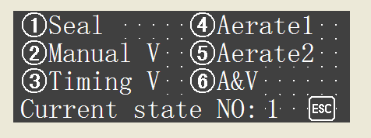
Then corresponds to the model of your choice and the choice of the number keys and press ENT key on the right side of the keyboard is recognized (Note:! Required and press ENT before entering the corresponding mode). And "Current State Number: N" is indicated by the current mode of operation has been confirmed, PLC operation instruction device according to the current mode of operation related.
*seal operation mode
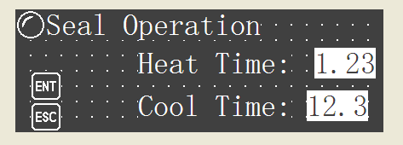
【Set the heating time and cooling time according the bag material and thickness】

Tip 1：If the current model is identified, then model electronic light in front of will on
Tip 2：Must use both hands respectively hold two sides of the bag, make the sealing part of the bag does not produce drape phenomenon, in order to ensure the sealing effect.
Tip 3：In every action (cycle) point move pedal switch for the first time, need to continue to trample until compressive bar down the movement to stop, if discovery is unusual, and in the process you need to let go of the pedal, compressive bar applications will automatically raise immediately!!
Tip 4：The second or third point move pedal can easy move, need not deliberately control point move time. Because the program has set a tamper-proof function.
Tip 5：If in order to get the vacuum time and cooling time and use of this model, please adjust through different related parameters, many experiments than the sealing effect. If you need different products in the same device packaging, and use different bags, please record the relevant data, in order to avoid change again will still need to test again when the varieties.
Tip 6：Remove packing finished action should be from one end of the mouth to the other end of the "split" must not integral to "open" because it is easy to cause of high-temperature tape on hot blade damage
Warning：Sealing operation mode is only for test data or improvised vacuum bag use, banned frequent use for a long time. For frequent use this pattern for a long time, please contact our company for custom-made
* Manual vacuum Mode
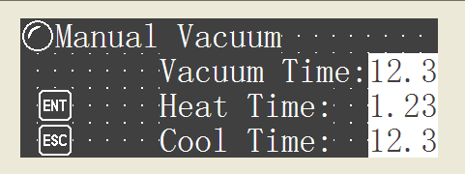
【Set the heating time and cooling time according the bag material and thickness；set the vacuuming time according the bag size and packing requirement】

Tip1：For the sake of safety, the machine for gas mouth to reach the set a delay, please be careful！
Tip2：In order to obtain good vacuum effect,Please try colse the gas mouth as much as possible
* Timing Vacuum Mode
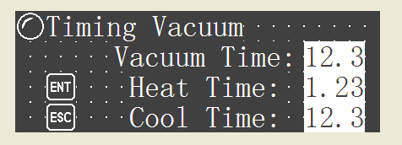
【Set the heating time and cooling time according the bag material and thickness；set the vacuuming time according the bag size and packing requirement】

*Air inflation model 1
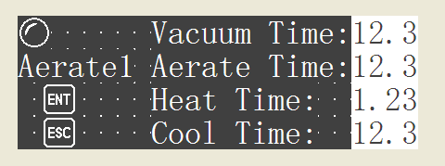
【Set the heating time and cooling time according the bag material and thickness；set the vacuuming time and Air inflation time according the bag size and packing requirement】

* Air inflation model 2
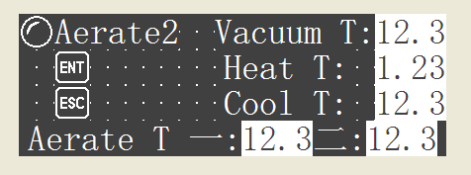
【Set the heating time and cooling time according the bag material and thickness；set the vacuuming time and Air inflation 1, Air inflation 2 time according the bag size and packing requirement】

*Air inflation vacuum mode
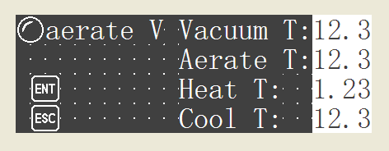
Set the heating time and cooling time according the bag material and thickness；set the vacuuming time and Air inflation 1 time according the bag size and packing requirement】

四、Machine maintenance
- Clean the air inlet filter
Some oil and water may separated by the air filter.Please check and clean the filter regular. Some foreign matters (small quantity of liquids, powder and particles) might be hidden on the cup of the air nozzle filter between the nozzle and exhaust pump Check and clean the cup regularly
- Clean the air outlet filter
The vacuum pump will suck the external air via air filter. The vacuum pump will not work efficiently if there is any dust or dirt on the cap. Therefore, clean the cup of the air filter every week.
- Vacuum oil monitoring and replaced
When using XD series oil type vacuum pump as vacuum equipment, it need to check the oil in regular time replace the vacuum oil as below setp if the oil need to be replaced：
  - Open the back cover can find the vacuum pump
  - Check the quality of the oil you can via bservation window；
③Release the old oil and fill the new vacuum oil
Note：if the packaging products containing dust or water vapor, the quality of the vacuum oil change faster. Need to change in time, otherwise will influence the effect of vacuum。
- Gas leaking solution
When found some piece of joint leak , please pull out the pipe and cut off the front end. Then pulg in again（Note：flat Incision）。Tip：Do press the release ring and pull the pipe out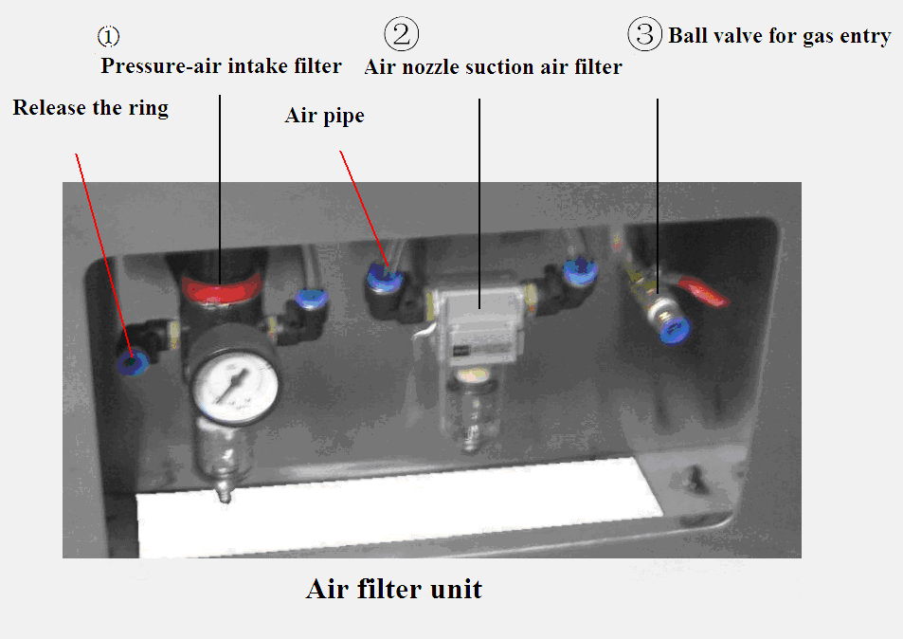

- Replace the high temperature tape
Pay attention to check the high temperature tape which pased on sealing blade up and down on the, when found some dirty, please clean or replace in time.
- The step as follow：
- ① loose the tabletting which pressed the spindle front and back
  - With one of the high temperature tape rotation do rolling, roll up and another about the volume for about 20 mm。
- Replace the heating blade
When found burned or deformation lead to the sealing effect is not ideal, please replace the blade in time。
The step as follow。
- loosen the two high temperature cloth scroll
- Then pull electrode compressive bar upwards, then loosen electrode screw
- While installing a new blade, fixed one end first, pull electrode compressive bar upwards,then fix the other end. Ensure the blade is perfectly straight after installation
- Sealer schematic diagram

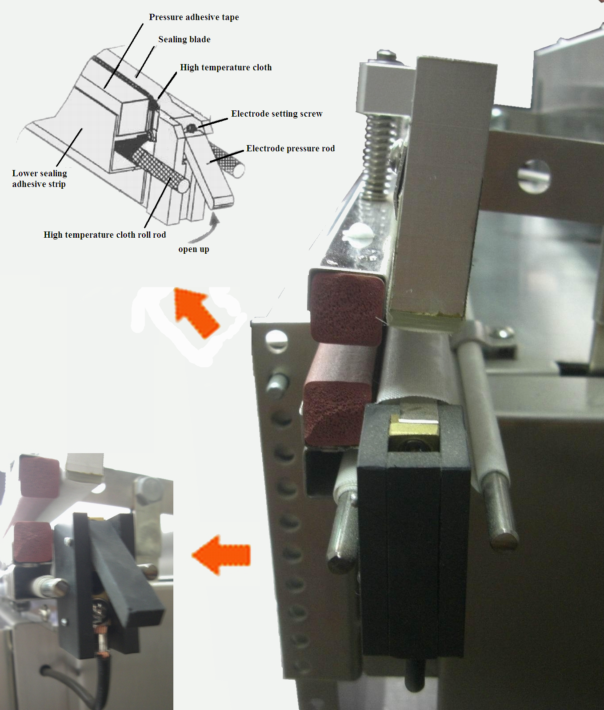

五、Routine Trouble Shooting
Problem | Cause | Method
Poor sealing | Heat blade, Teflon slice or silicon glue is dirty | Clean with cloth
Poor sealing | Teflon slice is damaged | Replace Teflon slice.
Poor sealing | Silicone is damaged | Replace or clean.
Poor sealing | Rubber belt is damaged | Replace rubber belt.
Poor sealing | Cooling time is too short. | When heating lamp is off, adjust the needle to cool for several seconds more.
Uneven sealing | Silicone is damaged or applied unevenly. | Replace silicone or use the other side.
Frequent rupture for heating blade. | Heating time is too long. | Adjust the needle to the shortest heating time when sealing can still work.
Frequent rupture for heating blade. | Cooling time is too short. | When heating lamp is off, adjust the needle to cool for several seconds more.
Frequent rupture for heating blade. | Rubber belt is damaged. | Replace rubber belt.
Frequent rupture for heating blade. | Blade failure. | Replace heating blade.
Though heating lamp is on, heating blade is not heated. | Heating blade is damaged. | Replace heating blade.
Though heating lamp is on, heating blade is not heated. | Inefficient solid state relay. | Contact us or our dealer. Replacing on your own may be dangerous.
Vacuum begins, but air is not discharged from the bag. | Nozzle is not placed in the bag. | Power off and restart.
Vacuum begins, but air is not discharged from the bag. | Vacuum is blocked by bag. | Let object close to nozzle for vacuum.
Vacuum begins, but air is not discharged from the bag. | Nozzle or strainer is dirty. | Clean nozzle and strainer.
Power light is on, and foot switch is pressed, but pedal does not go down. | Failure in foot switch. | Remove foot switch, and measure the resistance with a multimeter. When pressed, normally, the resistance is small, close to 0.
When pressing foot switch, pedal goes down, but when it is released, the pedal rises up immediately. | Upper sensor is wrongly placed to cylinder position. | Check whether the serial signal is on (105).
 | Retraction nozzle sensor is wrongly placed to nozzle position during sealing operation. | Check whether the serial signal is on.
 | Pushing gas nozzle sensor is wrongly placed to nozzle position during vacuum operation. | When select vacuum and press foot switch, gas nozzle moves forward. Check whether serial signal is on.
 | Middle sensor is wrongly placed to the cylinder position. | When sponge rod touches bag and the machine is ready to discharge, check whether serial signal is on.
Sealing operation is stopped (heating lamp is not kept on) | Starting sensor is wrongly placed to the cylinder position. | When heating begins, check whether the serial signal is on.

六、Accessories
- Electrical wiring diagram

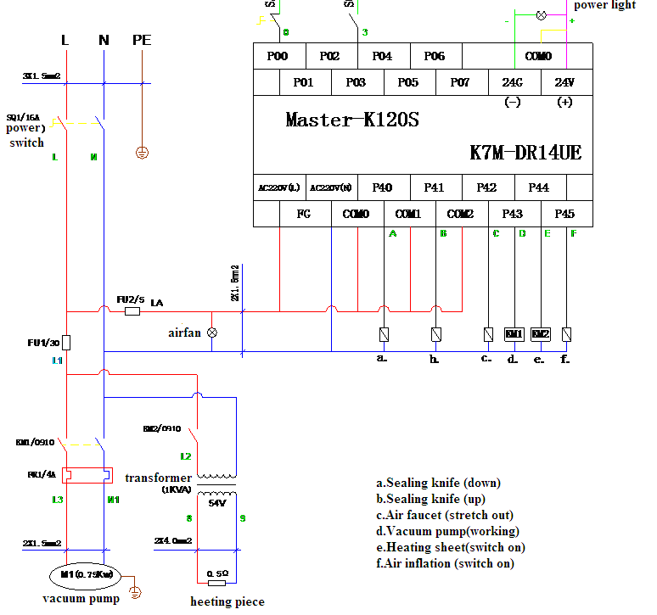
2.Packing List
- Operation manual………………………………1 pc
- Vacuum inflating packing machine……………1 set
- Heating sealer…………………………………1pc
- Cross screwdriver………………………………1pc
- Flat blade screwdriver…………………………1pc
- High temperature tape…………………………1 pairs（up and down ）
- High-pressure hose…………………………1 pc
- Foot switch………………………………………1pc
- Service record
Date | Item | approval | Notes
- Warranty card
Username：
Address：
Tel： Fax：
Date of purchase： Invoice number：
Model： Serial number：
Seller：
- Warranty instruction
Our machine warranty is 1 year. Start the date of purchase. The warranty content specific as below：
- Please provide relevant purchase vouchers.
- Before get the warranty. No longer reissue if purchase voucher is lost.
- The scope of this warranty is mainland China only, excluding Hong Kong, Macao and Taiwan
- Since the date of purchase, failure occurs under normal use, the company free of charge to repair the following content.
- Master control system
- Main motor
- Machine shell
Declaration: heating sealer and high temperature tape are wearing parts, not within the warranty scope
- In the following situations, even during the warranty period, The customer will not get free charge service
No valid purchase vouchers
Due to incorrect operation and power under the condition of instability
- Disasters (earthquake, fire, flood, artificial damage, etc.)
- Without my company permission refitted machine by self
- The machine sold to a third party
- Improper maintenance
- Inform us before get the machine repaired
- Probable reason for broken
- Date of broken
- Manufacturing number
- Date of purchase
- Our company will supply Technical Support and accessories if customer repair the machine by themselves.

